Now we are going to talk about component in react native
Component are teh basic and fundamental thing in React Native
Not only in react antive they are present in React js and also angualar , Vue and Larawel
Many technology uses teh concept of component
Alright the first thing the teacher willl tell is that What are compoennts and what are there types even with the help of an image he will mke us understand so tht you can understand it simply
Later we will see examples How to make component in same file (maybe dedicated to a component) and make compoent in seperate file and import it and use it
We will also discuss interview question


It is not teh last leesson for compoent in react native
Two or three lesson will definately come because the convept of component is too large and we need to understand this in detail because it is very usefull
Even teacehr is saing that whatever you see in screen is made with the help of component
Without component you cannot make anything in React native
Alright so we go to first qustion that is what is Component

If we go by definiation
They are compoent and reusable code simioar to function

By independent we means the code is independent of component
If theyb are similarnto function then call it function adn why do we call it component even
See inside you see the HTML part also which you will not find in function like you want to make text box , button and input box and radio button
you cannot display them with the help of function
When you put it inside a functiuon then it become by default a compoennt in React or Raeact js

On e hting remember is that when we make cfunctio then the name of teh first letter could be capital , small but when you make component then its first letter is capital
There are mainly two type of compoent and we will also study their sub categories which we will discuss in upcoming parts but for now there are two type components
One if function it is made like an ordinary function
and second is class based component and they are made like classes are made
So basically in old times it was used in React and react native
So in one part he tell us how to make class based component nd how to use it but the compoennt we made in the series will be functional and in tis part the example we are going to see will functional


Now in above screen what could be the compoennts the box you see above could be components and the manu bar you see it could be component
Now the property we told you of compoent are reusability
suppose ou make compoent related to username the component which give you user name now you ake it now you can use it anywhere you want you can use in other part of the screen and you can also use it in other screen So by this way it becomes reusable

By indepenednt we mean suppose we make component for user if we make change in other components like Contact list , Documents then there will be no impact on user component or teher will be no error becasue it is independent
If your base code haas error then it is different thing(maybe code shared by all the component)
When you make diufferetn different screen then different components are used there
For example if you are making an application then you make login screen and then make compoent there and when you logged in then the screen what will be opened after login then there also will be component
So as the teacher had said that whatever you see in UI is made with the help of components
So now we will practically implemented with the help of example

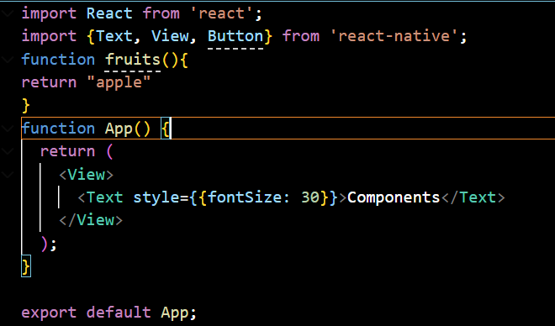
Now we see how components are made They are made same as you can see App above
It is a component itself
You can make component in teh same file ordifferent file
One compoennt can contain other component and also any oither compoent
You can nest it by any way

We make a component named as UserData
so make an arrow function or any other function named as UserData

Many people get confised that ths import functionality and arrow function are features of React no it is not they are the base features of javascript.
Now we retuen somrhing from it mainly tags or element or component

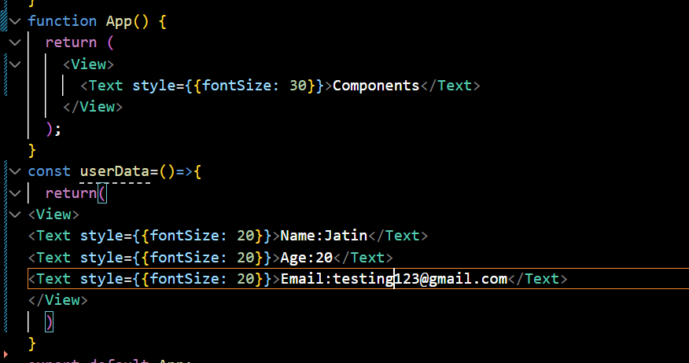
We do it like above and we are keeping it static for now but later make it dynamic with the help of Javascript
Now we made the component
biut has not used it So to use it so we will use it insiode the Appo component as it is teh root component so now the code will look like below

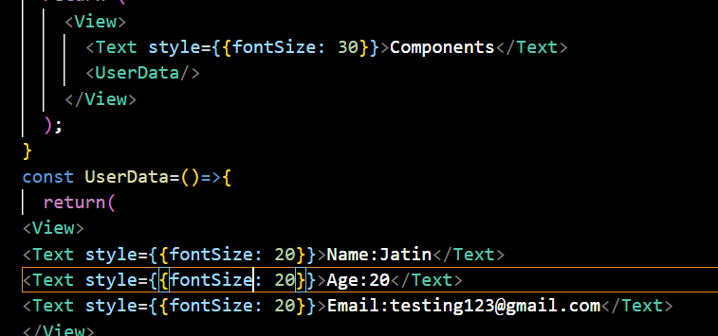
Now our UI will look like


Now suppose we use the component manu times then we see the same details again and again

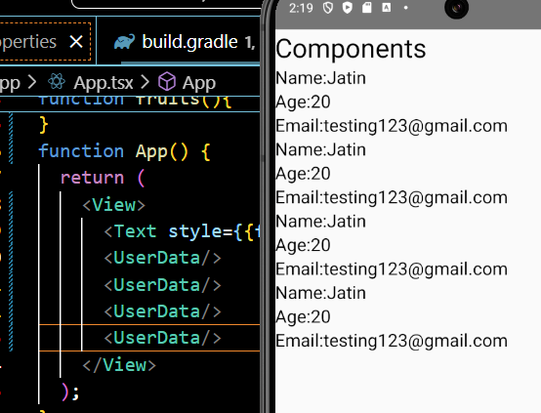
It is indepenedent in nature

Now we create another compoent named as Companydata
After it you can use component in any position in App then it will still work like we put user data compoennt belkow and CompanyData above
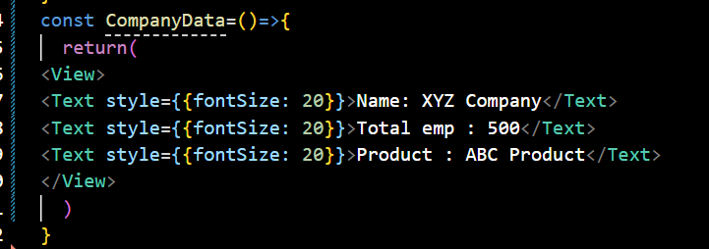
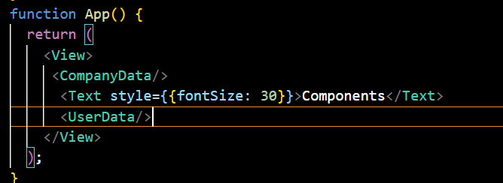
Now our output will be like below



Now if you want to create only two component then it is OK but if you want to do lots of work like creating 50-60 compomnent then you cannot plaace them in a single file For that you need to create different files It is a better way Even for every component you need to crete a different file
For now we have just used an example by placing differnet component in single file to show you reusability

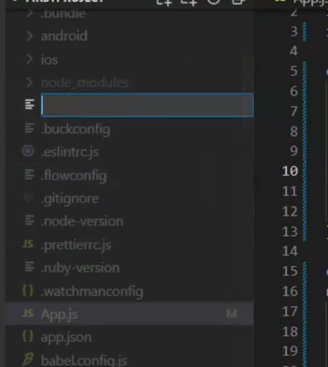
So you create a seperate file if you name the file and compoent name same then it will be easy for us to use it
By that you don't have to see the component naame in the file to use it and standard is maintained
So for that make a folder and name it components
Follow the standard and keep the folder name in small letters
Now inside we create a file CompanyData.js inside it
Now inside it paste teh comnpoent present inside App.js as shown below

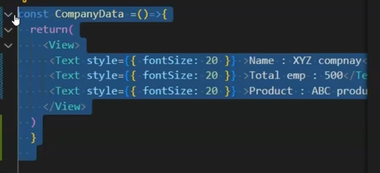
Now if after shifting it from App,js we run our app now an error will be shown in the output

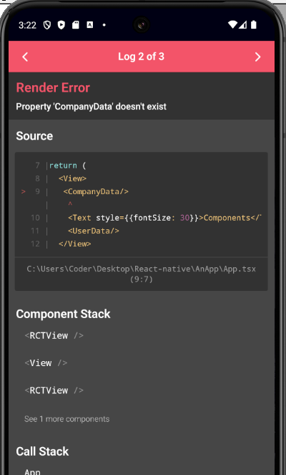
The error is that it could not find CompanyData component referenced in App.js

So we first import Text and View from react native in CompanyData.js and in end type the campamnd
export default CompanyData
Which means when henever this file will be imported then this compoentn will be imported by defaulr
if a component is not exported by default then you have to specifically mention it while importing it

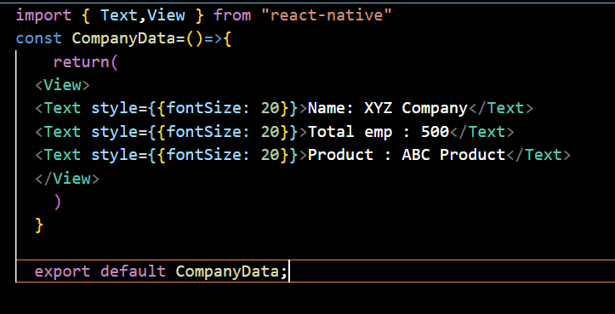

Now we import companyData inside App

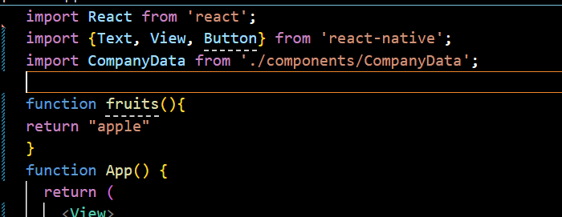
you don't have to use .js in file name in path if the compoanent while importing
12:25

Now if you bring vchange in teh content of the component in its file then its change will be reflected in the App

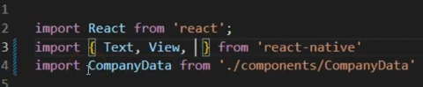
In our App.tsx file we imported React from 'react' but did not use brackests simlarly in case of our CompanyData Component but in the case of Text and View we used brackets to import why is it so
and what is the difference between normal export and default export s
Interview Question:-

Can we make a nested component

Yes we can do so like putting the CompanyData component inside the Userdata component

What is the difference between Component and a Function

They can ask you example of reusable component then you can tell so

You can give an example of an header which is usually present on every screen

